
Partner Contact Info
Auto/Home/Pet Insurance 

Liberty Mutual offers Educators Plus which is recognized as one of the premier automobile and homeowner insurance programs in the nation. With Educators Plus, the normal deductible is waived if the policyholder’s car is vandalized or stolen while on school property. And, Liberty Mutual now offers Pet Insurance. Call 855-514-6787 or Visit www.libertymutual.com/fea
Members Only Enrollments 
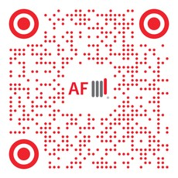
American Fidelity has partnered with Creative Benefits to provide key insurance programs to members at the worksite, featuring convenient payment through payroll deduction. These “Members Only” enrollments have also proven to be a successful membership recruitment tool.
Call 877-425-1104 or Email afes-fl@americanfidelity.com
Emergency Loans 

BMG Money offers LoansAtWork to help employees and members responsibly manage emergency expenses. LoansAtWork is available even to those members who need help the most due to low credit scores — but unlike payday lenders, it comes at a reasonable cost.
Call 800-319-5306 or Email derek.elgin@bmgmoney.com
Financial Guidance 

Educators Choice offers a dedicated relationship banking team providing personalized assistance from convenient access to open a membership through knowledgeable product/service guidance and support – all based on individual situations, personal financial needs, and life goals.
Call 855-201-5700 or Email info@educatorschoice.com
www.cbeducators.com  rgrady@cbeducators.com

